
ISO 9001 IQ N ET CERTIFIED


Powerstar System Development and Main Contractor Ltd.
H-1039 Budapest, Nagyvárad u. 11-17
Tel: (36 -1)-2400-350, (36-1)-2400-352, Fax: (36 -1) 2400-349
Home page: www.powerstar.hu E-Mail: office@mail.powerstar.hu

The name of the company:
POWERSTAR System Development and Main Contractor Limited Company
/shortly: POWERSTAR Ltd./
Company address: H-1039 Budapest, Nagyvarad u. 11-17.

Home page: www.powerstar.hu
E-Mail: office@mail.powerstar.hu

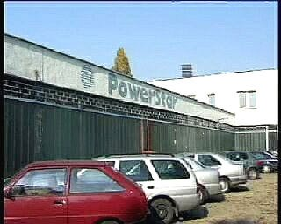
Foundation:
23.12.1991.

The date of company registration:
14.02.1992.

Company registration number:
0109162816/91/3

The share capital:
50.000.000 HUF

The owners:
Hungarian personals 100 %

The Powerstar factory

The main scopes of company:
Manufacture of electric distribut ion and regulation equipment
Repair of equipment and machines in the electric industry
Manufacture of component part in telecommunication and electronics
Manufacture of industrial special power supply systems for telecommunication products Repair of industrial special power supply systems for telecommunication products Export / Import
Making, consulting and selling of software
Manufacture of solar systems

Features of product:
Custom design and standard racks.
Optional microprocessor controller for the system functions Single or three-phase AC distribution and protection systems D.C. distribution and protection systems
Optional Low Voltage Disconnect
Optional batteries for the systems
ISO 2000; 9001 certified
Over 4000 installat ions throughout Hungary, Czech, Ukraine, Slovakia, Romania, and China
Recognition Diploma from Hungarian Innovation Foundation
MARTA prize (1998) The Best Hungarian Product

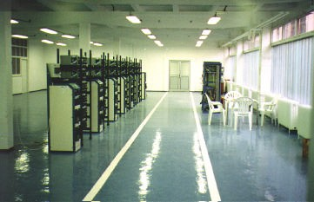
Place of production

References
Technical conditions:
Total area: 1680qm in which: Production 790qm
Test department 130qm
Stores 620qm Development 120qm Offices and
social units 400qm

ERICSSON, WESTEL for GSM base stations
ERICSSON, SIEMENS, MOTOROLA, MATAV for district and rural base stations MVMT (Hungarian Energy Company) for telecommunication and information centres MOL (Hungarian Oil Company) for information centres and gas pipeline base
stations
HUNGARIAN ARMY for telecom stations and airports lighting ANTENNA HUNGARIA for telecom and microwave stations ATLAS TELECOM for telecom stations
HUNGARIAN RAILWAYS for telecommunication and information centres
Small telephone exchanges for companies
Photovoltaic Solar Systems (Hungary, Libya, Kuwait, Croatia)

Partner companies

ERSKINE SYSTEM CO ENGLAND
EA-ELEKTRO AUTOMATIC GMBH ENGLAND
C&D CHARTER POWER SYSTEM CO USA
APC AMERICAN POWER CONVERSION USA
GAMATRONIC ELECTRONIC INDUSTRIES LTD FARNELL
SHENZEN SETEC POWER CO LTD. CHINA
MEAN WELL ENTERPRISES CO TAIWAN CLEENTEX MED CO EGYPT

